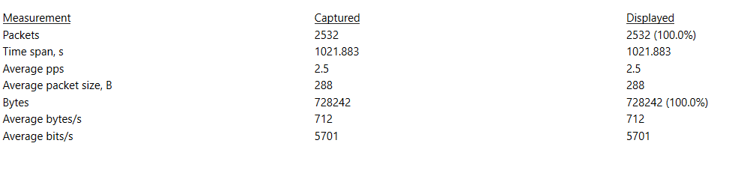

This is a clip from a capture packet files properties pop- up window screen. There are 2532 packets captured. This was a packet capture demonstration showing how Wireshark works for an audience that is not technically inclined. Among the packets were route advertisements, neighbor advertisements, neighbor solicitations, keep alive tcp packets. A multicast domain name server was captured:
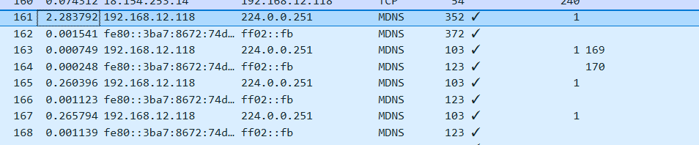

The computer in question is the one used to write this report.

